PrimerChecker℠ Manual

H. F. Espitia-Navarro

17 January 2019

# Graphic Interface Elements

PrimerChecker comprises three main parts which contain all the controls that provide all the functionalities and documentation available: Navigation Bar, Parameters Panel and Quality Plot Panel

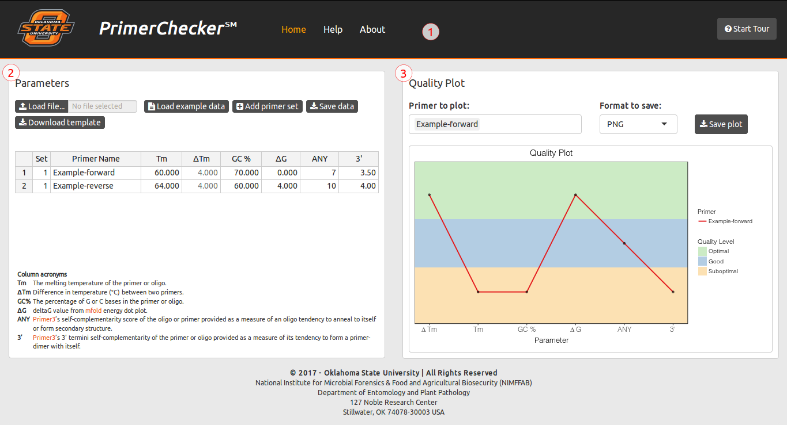PrimerChecker Main Interface and it main parts: (1) Navigation Bar, (2) Parameters Panel, and (3) Quality Plot Panel

## Navigation Bar

This part contains the links to the sections of the Web application. The ‘Home’ link redirects to the main interface of the application. The ‘Help’ link shows the help content of PrimerChecker℠ (FAQs and Manual). The ‘About’ link redirects to the general description about PrimerChecker℠, credits and disclaimer note.

The Navigation Bar also contains the ‘Start Tour’ button which launch the application tour that shows the basics of PrimerChecker℠ functionalities.

Navigation Bar

## Parameters Panel

This panel allows to enter primers parameters data and provides controls to load new datasets and save them to a file. It comprises three parts: The Control Bar, the Input Parameters Table, and the Acronyms Table.

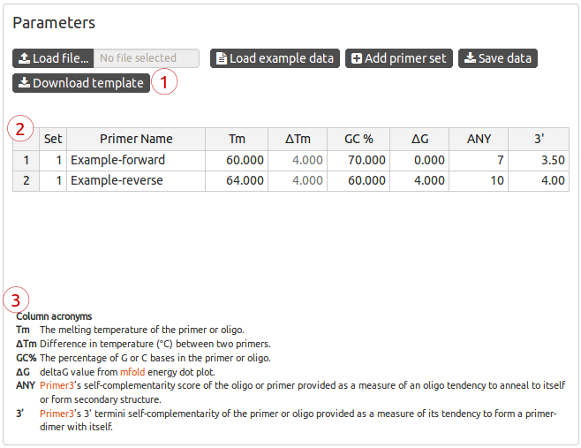Elements of the Parameters Panel: (1) Control Bar, (2) Input Parameters Table, and (3) Acronyms Table

### Control Bar

Provides the buttons to execute actions related to the input parameters table:

#### Load file

Load file buttonLoad file button

You can load your own primer parameters data set using this button instead of editing the values present in the table. The file format can be MS Excel (.xls), OpenDocument spreadsheet (.ods), or text with tab separated values (.tsv, .txt). You can see more details about the file format in the section File Formats of this manual.

After clicking this button, you will see a window to select the file to upload. Once you have picked your file, PrimerChecker℠ will start the file uploading, and will show an orange bar that indicate the progress of the upload. When the file is successfully uploaded, you will see the dataset in the Input Parameters Table and its corresponding plot:

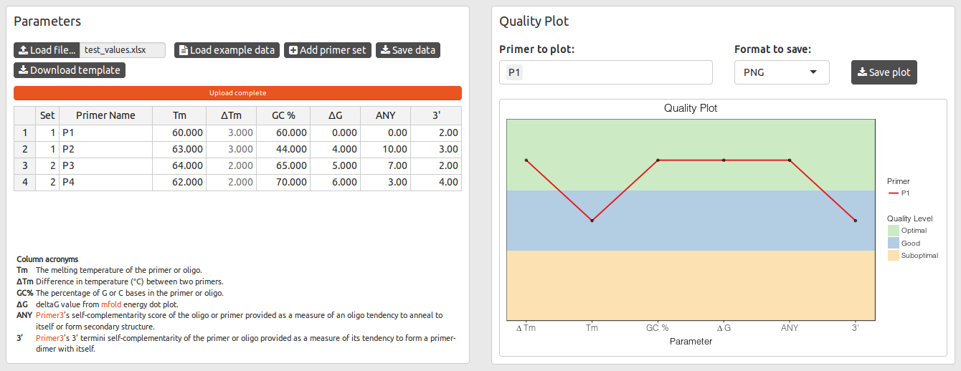File successfully uploaded

If the uploaded file does not have the appropriate format, you will see this error message instead the Input Parameters Table:

Invalid format. Please select a valid data file or load the example data to start.

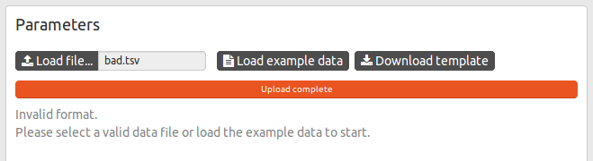Bad file format error message displayed instead the Input Parameters Table

To be sure that you have the appropriate format before to edit your data offline, please download the MS Excel template file using the ‘Download template’ button.

#### Load example data

Load example data buttonLoad example data button

Use this button to load an example dataset of two primers. Please note that by using this button, you will reset the table to its initial state, losing any unsaved data in the table.

#### Add primer set

Add primer set buttonAdd primer set button

Use this button to add a new pair of primer’s parameters (two new rows) and start editing.

#### Save data

Save data buttonSave data button

Use this button to save the current information in the table into an MS Excel file (.xlsx).

#### Download template

Download template buttonDownload template button

Use this button to download an MS Excel template file to enter your data and upload it after to PrimerChecker℠.

### Input Parameters Table

Use this table to enter the primers parameters. You can modify the values of the table by editing cells in the same way that in a spreadsheet application (e.g. MS Excel or LibreOffice Calc).

* Double click or <Enter> key over a cell activates the edition of the current value.
* Right click over the table shows a context menu with edit actions: insert/remove rows, undoing last changes and cell alignment.

#### Columns

| **Column** | **Description** |
| --- | --- |
| Set | The number id of each set of primers (forward and reverse). The same id can only be in two primers (two rows). |
| Primer Name | The name of the primer. |
| Tm | The melting temperature of the primer or oligo. |
| ΔTm | Difference in temperature (°C) between two primers. |
| GC% | The percentage of G or C bases in the primer or oligo. |
| ΔG | deltaG value from mfold energy dot plot. |
| ANY | Primer3’s self-complementarity score of the oligo or primer provided as a measure of an oligo tendency to anneal to itself or form secondary structure. |
| 3’ | Primer3’s 3’ termini self-complementarity of the primer or oligo provided as a measure of its tendency to form a primer-dimer with itself. |
| ANY Comp. | Primer3’s self-complementarity score of the pair of oligo or primers provided as a measure of an oligo tendency to anneal to itself or form secondary structure. |
| 3’ Comp. | Primer3’s 3’ termini self-complementarity of the pair of primers or oligos provided as a measure of its tendency to form a primer-dimer with itself. |

## Quality Plot Panel

This panel shows the quality plot and provides controls to export the plot to an image file.

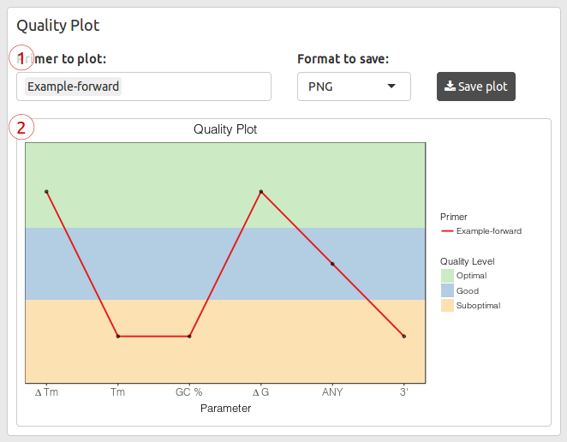Elements of the Quality Plot Panel: (1) Control area, (2) Quality plot

### Control area

Provides the elements to control the primers to be plotted and the output image format, as well as the button to save the plot to an image file.

### Primers to Plot

You can select the specific primers you want to plot by using this list. Click from the list the primers you want to plot. To remove a primer, select it and press <Del> or <Backspace> key in your keyboard.

Primers to plot selection listPrimers to plot selection list

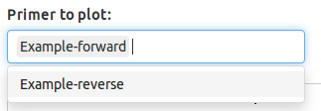Selecting primers to plot from list

### Format to Save

Use this list to select the output image file format of the plot. You can choose among the popular PNG and JPG or the high-quality and publication-ready formats PDF, EPS, SVG, and TIFF.

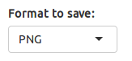Format to save selection list

### Save plot

When you are satisfied with your plot, you can save it on a file using this button.

Save plot buttonSave plot button

# File Formats

The allowed file formats for uploading datasets are MS Excel (.xlsx and .xls), OpenDocument spreadsheet (.ods) and tab separated values (.tsv, .txt) text file.

You must preserve the columns, order and properties showed in the following table:

|  |  |  |
| --- | --- | --- |
| # | Column | Data Type |
| 1 | Set | Numeric (integer) |
| 2 | Name | Character |
| 3 | Tm | Numeric (decimal) |
| 4 | GC_perc | Numeric (decimal) |
| 5 | Delta_G | Numeric (decimal) |
| 6 | ANY | Numeric (integer) |
| 7 | Three_prime | Numeric (decimal) |
| 8 | ANY_comp | Numeric (decimal) |
| 9 | Three_prime_comp | Numeric (decimal) |

Note that column names can be different from those displayed in the PrimerChecker Input Parameters Table but preserving order and data type.

An example of a dataset in a tab separated values (.tsv) file is the following:

set primer tm gcPerc dG any threePrime anyComp threePrimeComp  
1 P1 60.0 60.0 0.0 0 2.0 1 1.2  
1 P2 63.0 44.0 4.0 10 3.0 1 1.2  
2 P3 64.0 65.0 5.0 7 2.0 1 1.2  
2 P4 62.0 70.0 6.0 3 4.0 1 1.2